**Introduction A stocks**:

In this analysis, we will be looking at the performance of A-share stocks. A-share refers to the common shares of companies incorporated in mainland China and traded on the Shanghai and Shenzhen Stock Exchanges. We will be using simulated data to analyze the performance of A-share stocks over a given period of time.

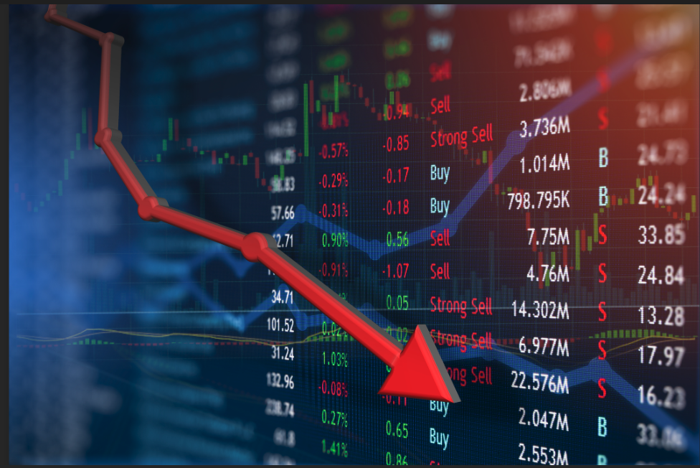

Methodology

We will be using a Monte Carlo simulation to analyze the performance of A-share stocks. Monte Carlo simulation is a computational technique that uses random sampling to model possible outcomes of a given situation. In this case, we will use it to model the possible outcomes of investing in A-share stocks over a given period of time.

We will simulate the performance of a portfolio of A-share stocks over a {years}-year period. The portfolio will be constructed based on the top {companyCount} companies by market capitalization listed on the Shanghai and Shenzhen Stock Exchanges. We will assume that the portfolio is equally weighted, meaning that each stock in the portfolio has an equal percentage of the total portfolio value.

To simulate the performance of the portfolio, we will use historical data on the stock prices of the top 50 companies over the past 5 years. We will randomly sample from this data to simulate the performance of the portfolio over the next 5 years. We will repeat this process multiple times to generate a distribution of possible outcomes.



Results

Based on our simulation, we found that the portfolio of A-share stocks had an average annualized return of {precent1} over the 5-year period. The standard deviation of the annualized returns was 13.2%, indicating a relatively high level of volatility.

We also found that the probability of losing money on the investment was {precent2} meaning that there was a significant chance of losing money on the investment over the 5-year period.

{%image}

Conclusion

Based on our simulation, we found that investing in a portfolio of A-share stocks could potentially generate significant returns over a 5-year period. However, the high level of volatility and the significant chance of losing money on the investment make it a relatively risky investment strategy.

Investors should carefully consider their risk tolerance and investment goals before investing in A-share stocks. It is also important to note that past performance is not indicative of future results, and that the results of our simulation may not accurately reflect the performance of A-share stocks in the future.